**Table of Content**

Team Members…………………………………………………………………………………..2

Guyer’s “B.E.S.T.” Robot ............................................................................................................3

Offensive & Defensive………………………………………………………………….............5

Brainstorming Approaches ……………………………………………………………………..6

Robot Design and Modifications...……………..........…………………………….…………....7

Safety…………………………………………………………………………………..……….11

Support Documentation……………………………………………………………………..….13

**Team Members**

|  |  |  |
| --- | --- | --- |
| **Name** | **Grade Level** | **Primary Role(s)** |
| Morgan Allen | 12 | Programming |
| Gretchen Belinski | 9 | Design, Construction |
| Miguel Benitez | 11 | Notebook, Construction |
| Harrison Daniels | 11 | Programming, Design, Construction |
| Ibi Eni | 11 | Notebook, Construction |
| James Ferguson | 11 | Construction |
| Nathan Gates | 12 | Design, Construction, Physics consultant |
| Tanner Hornsby | 10 | Treasurer, Construction |
| Rachel Hughes | 11 | Public Relations Manager |
| Connor Jenkins | 9 | Construction, T-shirt |
| Hyun-Jae Kim | 12 | Construction |
| Jean Kim | 11 | Construction |
| Justin Koh | 12 | Documentation, T-shirt |
| Teresa Lee | 12 | Design, Construction |
| Yubin Lim | 10 | Construction |
| Karen Lin | 9 | Construction, Fundraising |
| Anthony Roth-Giacinto | 12 | Brainstorming, PR assistant |
| Nick Taylor | 12 | Design, Construction Supervisor |
| Cooper Vennell | 11 | Design, Construction |
| Rajan Vyas | 12 | Construction |
| Andrew Winn | 12 | Design Supervisor |
| August Worley | 12 | Design, Construction |

**Guyer’s “B.E.S.T.” Robot**

Given the 2017 B.E.S.T. Robotics Competition theme of ‘firefighting,’ our team decided to incorporate the essential elements of *fighting fire.* We began with identifying the most fundamental aspects of the Irving Fire Department’s line of work. Robust response, effectively extinguishing fires, and most importantly, saving lives. Our technology is characterized by these three core functions. The densely populated but also wide-spread residential region makes the basics all the more crucial in remaining effective. Although structure fires remain consistent for obvious reasons across the world, our specific surrounding environment causes greater need for superior logistics. Specifically, the Irving Fire Department faces challenges in strategically partitioning fire stations/equipment to meet the minimum standard of fifteen firefighters on scene in under eight minutes. Our team found that the most applicable point was movement, in order to help meet the conditions of the tournament and to best emulate it’s theme. Unique environmental limitations include the intense heat during the hotter seasons in the North Texas region. There are various systems in place that rehab firefighters before sending them back into fires. These involve rotating crews to lower risk of heat emergencies in the firefighters and to regulate hydration levels.

“Know your job, do your job, be nice.”- Phoenix Fire Chief Alan Brunacini revolutionized the principles of firefighting. He was the first to look at the citizens he served as customers, and that providing exceptional service to the community yielded benefits and support tenfold. He embodied the idea of ‘give to receive.’ At the end of the day, the only tangible thing that matters is devoted service to the people, for the people. The face-value of the competition is defined by the tasks each robot performs, however the theme of firefighting should embody the values of the brilliant men and women who stood testament to genuine community service.

The physics behind ‘putting out fires’ in the competition, while obviously on a much less complex scale, correlates with the physics behind water hoses on firetrucks. From the separation of the three heat zones, to the launching mechanism on the robot, we as a team are meant to create creative versions of a simple model of putting out fires. Having whiffle balls as ammo for the launching mechanism is a simple way to emulate the path of water in the air due to its light make-up. The competition tasks require us as a team to apply our knowledge of physics (as well as some calculus) to create a consistent robot. At Guyer, we took these core values behind the theme of the competition and used them as the foundation for what became our robot.

**Offensive/ Defensive Strategy**

Upon the release of the 2017-2018 game rules and point system, we began the creation of our strategy. After many days of analyzing the game and field, we were able to create a strategy. Our basic game plan consisted of getting the most amount of points in the shortest amount of time allotted with little effort exerted.

To adhere to the plan, we needed to collect the mannequin due to its time bonus and a number of points that it would increase the accumulated 120 points by a varying sum that can improve our overall score quite drastically. Following the collection of the Manikin, we focused our energy on the collection of the print drums. Knowing that the cans would vary in weight picking them all up at once was not a viable option when manually controlling the robot from afar plus designing a mechanism capable of picking all three of them in an upright orientation would prove too difficult. To work around this, we determined that ramming the robot into the paint cans and knocking them over would make it considerably easier for the robot to roll the cans onto some sort of bed horizontal orientation rather than attempt to pick it up with a claw. Using this method, we would aim to collect two out of the three cans.

Finally, the robot will return to the start box where the spotter would begin loading the balls for it to shoot at the fire cups and aim to hit the fire by driving next to score as many points as possible during the rest the allotted time. The reason for doing it last is the limited amount of shots we would have and small frequency of us hitting the cup resulting in the accumulation of points.

**Brainstorming**

Our team has built up experiences over the past few years, and first we considered the advantages/disadvantages from our past projects. Afterwards, we prioritized efficiency and the ability of the robot to be able to do multiple tasks.

Throughout the season we knew size and simplicity will make us reach our goal faster. Such as, figuring out the material to properly build the base of the robot or knowing a simple way to construct a shooting. This were things that we thought through the beginning to make sure we had a successful outcome. Similarly, we focused on things which are more useful, usually things that can do multiple tasks. For example, we proposed a PVC next to the wheels in which it would help with movement, amount of motor use, and drag many the mannequin. Another idea proposed was the gate and winch in which it will pick up paint cans and be able to pick up the balls. Implying, the efficiency our team was trying to build for the performance.

In addition, not only we needed ideas for our robot, but our way to work as a group. Since, our group was fairly big we could have people focus in different tasks rather than having a slow progress on each individual task. Such as, having different groups focus on things like programming, wheels, mechanisms, or firing gun. This shows our approach towards having an effective team to have efficiency.

At the end, our robot has been successfully built with a reasonable size and simple ideas. This was because of the experiences from past competitions and built back on our mistakes. Also, the fact that our team contributions were distributed helped with efficiency. Overall, our brainstorming for the competition helped us be successful with the process of the competition.

**Robot Design and Modifications**

Following the initial brainstorming and stages, we began work on constructing the robot and determining how to build the components based off of the task we had decided to complete. In order to complete the robot in the allotted time, we delegated the production of each part to a different group to work on. This allowed for multiple things to be in the development and construction cycle at the same (anywhere from 2-3 things), minimizing the amount of time it takes to fully construct the robot. Each team had a specific amount -of building objectives that were required to complete the component the components while functioning as an informal completion timeline.

|  |  |  |
| --- | --- | --- |
| **Component** | **Purpose** | **Building Objectives** |
| Chassis | House all of other components and possible modules. | -Measure and Assemble PVC Outline  -Attach wooden boards |
| Winch and Gate | Hoist up paint cans, and possibly stray water balls. | -Secure gate to chassis  -Erect atm posts to the PVC outline  -Insert crossbar between arms  -Attach drive motor  -Connect strings to the gate and drive motor |
| Drive Wheels | Allow the robot to move. | -Cut Styrofoam and wooden circles  -Glue Styrofoam and wood to each other  -Drill holes into wheels  -Attach wheels to drive Motors |
| Rotational Wheel | Allows the Robot to turn easily and provide more mobility. | -Connect Wheel to ball bearing spinner  -Attach to the front underside of the robot. |
| Firing Mechanism | Propel the water projectiles towards the No Entry Zone. | -Wooden Gear and Track  -Crank Servo and Pulling Mechanism  -Firing track/ Loading bay |

Robot Chassis

The first thing that was constructed was the chassis and was completed rather quickly based on the original blueprints with little to no problems. The original design was a PVC support frame with wood boards drilled to the edges allowing components and modules to be fixed onto. Some modifications were changed to the chassis to allow components to fit requiring the wood to be cut down and reshaped to create the necessary space. Another modification to the chassis was the inclusion of a secondary board under the main one as to mount the non-drive wheel used for turning. Additional wooden rectangles were added in order for the wheel to be attached in its proper location.

Winch/Drawbridge Mechanisms

The winch system drawbridge system itself went through two different iterations. The first of which was a drawbridge hoisted by two strings attached to pulleys that were affixed to an elevated rod. This bar was rotated using a gear track mounted onto the same bar as the pulleys and a motor fixed to the front board of the chassis which powered the system. After completion, the system was tweaked here and there to affix the strings to the proper length and ensure that it would work correctly.   
 Later on, the system was revised eliminating the pulleys and gear track mechanism opting for only the drive motor with the string attached and hoisted over the elevated rod and then connected to the gate similar to the last system. One of the reasons for the change is due to the lack of reliability of the previous design in the gear track system with its frequent track slips and slow lowering and raising of the gate.  
 Following the gates completion, we came to the realization that the game itself would not be able to effectively collect the cans and stay water balls without the addition of some sort of sweeping arms to keep the cans in place prompting the creation of sweeping arms to move the balls and cans onto the gate and keep them secured.

Movement

The robot is capable of movement with two wide drive wheels affixed to both sides of the base with a third wheel fixed underneath the robot capable of turning left and right in a swiveling fashion like the front wheels on most shopping carts or trolleys. Before the integration of a swivel wheel in the front of the robot, another alternative was to give a PVC support or elbow that would rub against the ground and function similar to the wheel wheel but was not used due to the amount of friction it would create and the decrease limited maneuverability compared to the other option.  
 When designing the main drive wheels, we decided to use wheels with a large diameter with a decent width. While this would decrease our speed, it would, in turn, create much more torque, allowing the robot to traverse the field easier and make driving the robot simpler for the driver. To achieve these two thin wooden circles were cut to the same specification while a third was made out of Styrofoam and cut in the same fashion. Then all the Styrofoam circle was glued between the two wooden ones and the circumference surrounded in grip tape to create traction and ten holes drilled equidistant from each other to reduce the weight and still provide enough structural support. This process was later repeated for the second wheel.

Firing Mechanism

When trying to come up with an effective firing mechanism, the team unanimously wanted to have an automatic loading mechanism but quickly eliminated the use of a hopper where the balls were fed in from the top because of the amount of unnecessary intricacy

**Safety**

During the construction of the robot, we took several measures to ensure the safety of all members of the club. For starters, four of our members are OSHA certified, meaning they have undergone a ten-hour training course over general construction and occupational safety. With all this, we established a foundation on our team to eliminate the malpractices of tasks.

In August our main priority was to establish ground rules that will promote safety at all cause. Over the past few years, our team has struggled with completing certain tasks since few of our members have the skills to perform a certain task. This year we implemented a method from one of our mentors called PIPE, and it has shown a great significance with the production quality over the season. PIPE stands for Perspective, Inspection, Protection, and Execution; furthermore, this method created an easier way for all of our members to be participating in the project. Perspective, which could be described as a point of view, creates a way for the person to analyze if the way they want to achieve a certain task is effective, and if it is ineffective the person needs to find another process to finish their task. Completion of the step above will determine the range of risk involved; therefore, Inspection is the next step which approved by an individual (usually OSHA certified) or the sponsor to see if the strategy taken place is safe and effective. Once this is approved protection needs to be taken place. Afterwards, the final step is to execute which is where you must start what you finished, and you are the only one who can finish it. Concluding, the PIPE method had shown a major reduction of injuries and shows the promotion of involvement in our team.

Other than the PIPE method our team members are encouraged to help each other and learn more about the different procedures. For example, when we were building the wheels for our robot, we tried to learn the power tools needed. Experiences increase more knowledge and strategies to reduce the number of risks presented. Similarly, the encouragement of working as a team has minimized many of our errors since we’ve seen the many opinions a group has to offer. Overall, working with peers and engaging in multiple activities together has helped us be successful at completing a task which conveys a way to decrease the level of risk.

Above all, we have shown that based on our methods of completing tasks the level of risks has decreased while out level has increased.

**Support Documentation**

This section has been divided into multiple to show a better understanding and quality of each section in this notebook.

Offensive/Defensive

Figure 1.1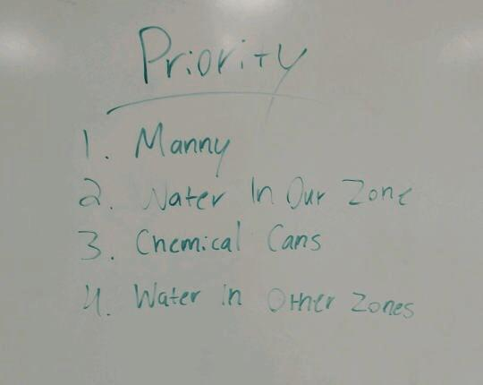

Shows our game plan at the beginning which our thoughtfulness the strategies at the beginning

Figure 1.2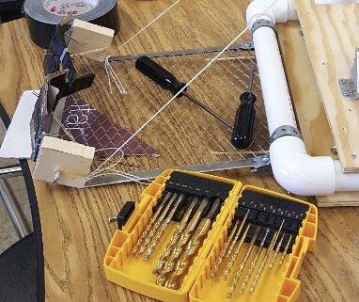

Our gate which it will be able to do the first tasks in this case rescuing Manny and later on the chemical cans

Brainstorming

Figure 2.1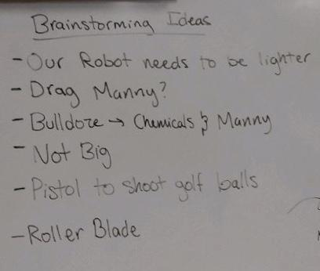

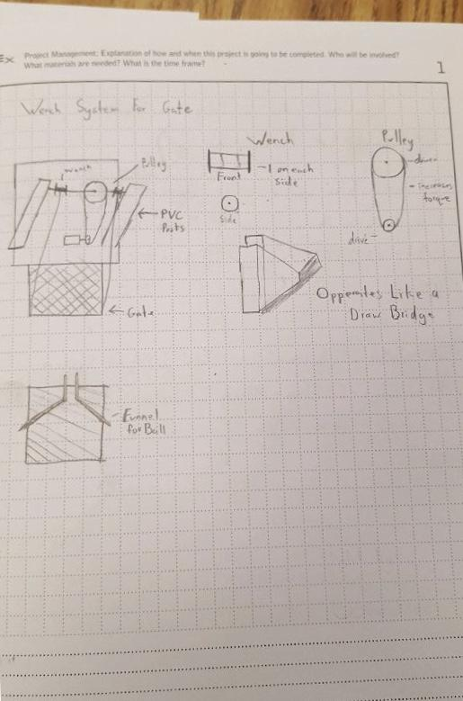 After knowing the certain tasks, we have to think about how to do them. Figure 2.1 shows our way of taking our time to make the robot efficient.

Figure 2.2

Sketches of the different components of our robot

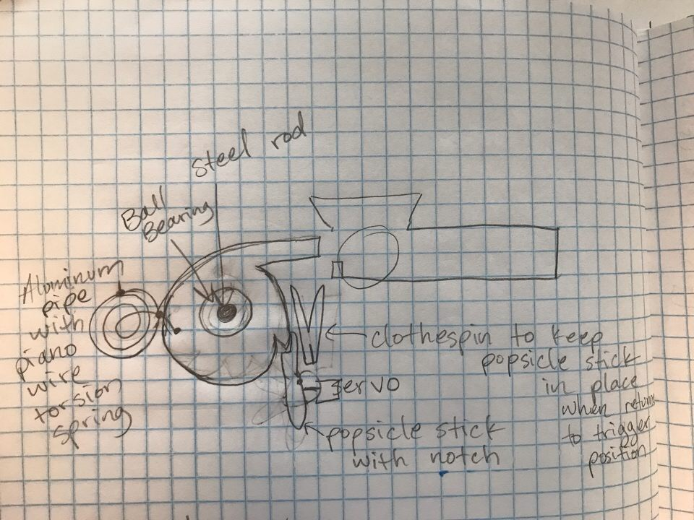

Figure 2.3

Design Process/Construction

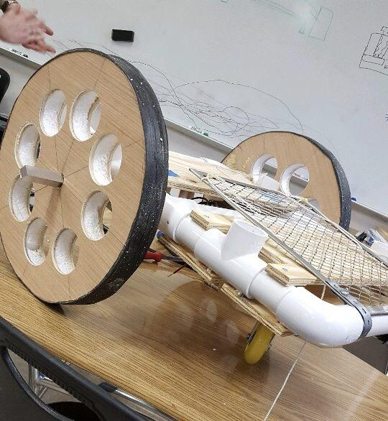

Figure 3.1

Shows our standard base with mounted wheels and gate

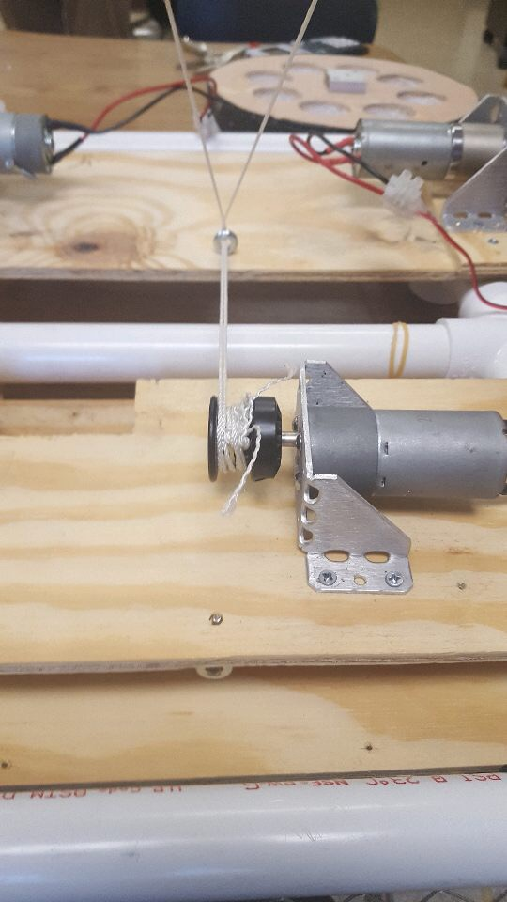

Figure 3.2

Shows our motor mounts for gate and wheels

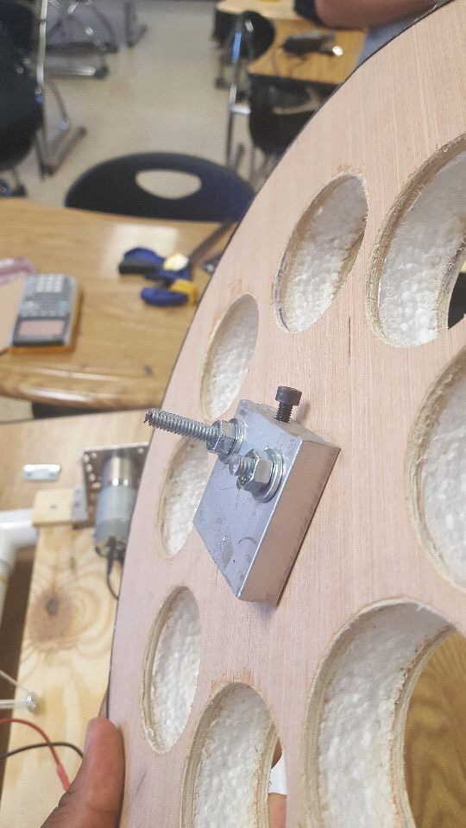

Figure 3.3

Wheel with the motor connector ready to be mounted

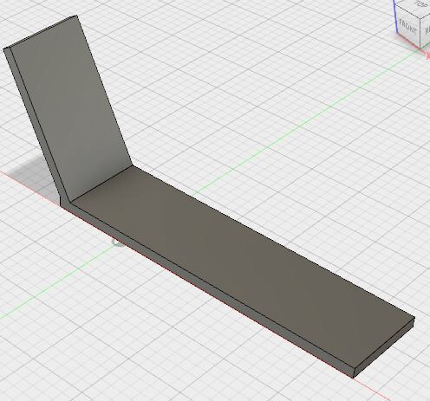

Figure 3.4

CAD drawing for the winch which is attached to the gate

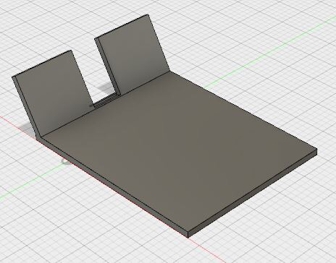

Figure 3.5

CAD drawing for gate with winches attached

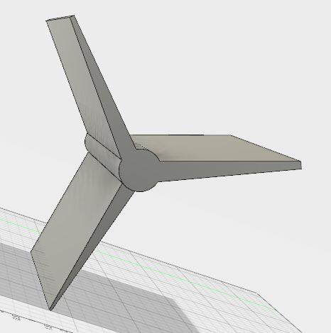

Figure 3.6

CAD drawing for a special piece in our shooting mechanism

Math/Calculations

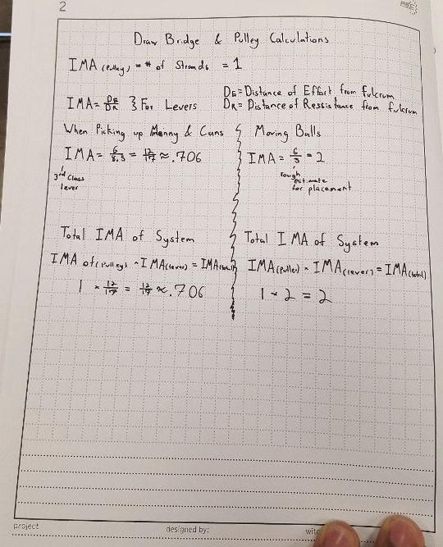

Figure 4.1

IMA calculations for drawbridge and pulley

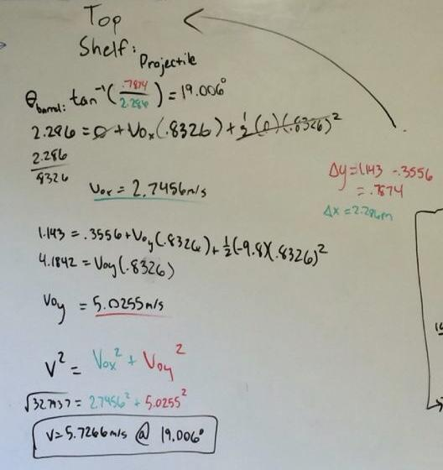

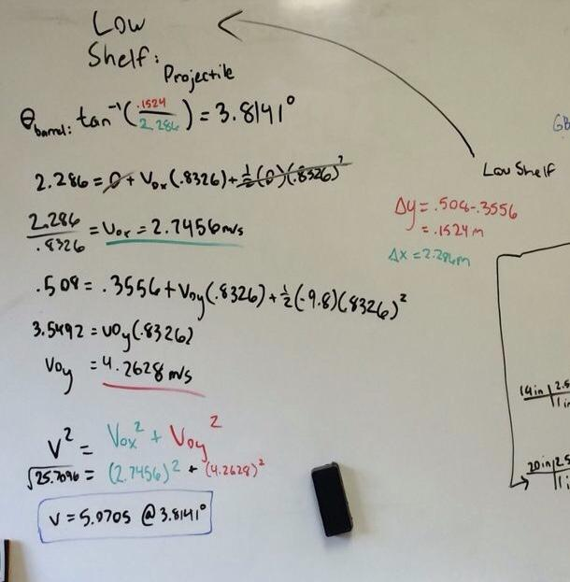

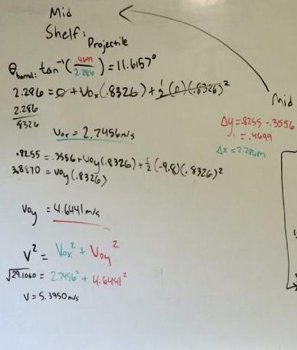

For Figure 4.2,3,4 we demonstrate our calculation for the firing mechanism through projectile motion physics.

Safety

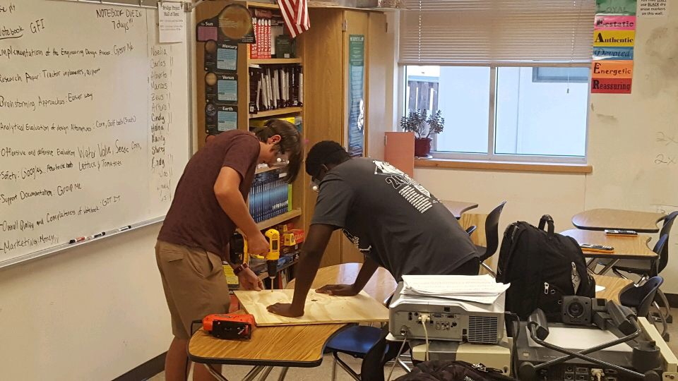

Figure 5.1

Demonstrates effective safety procedures taking place

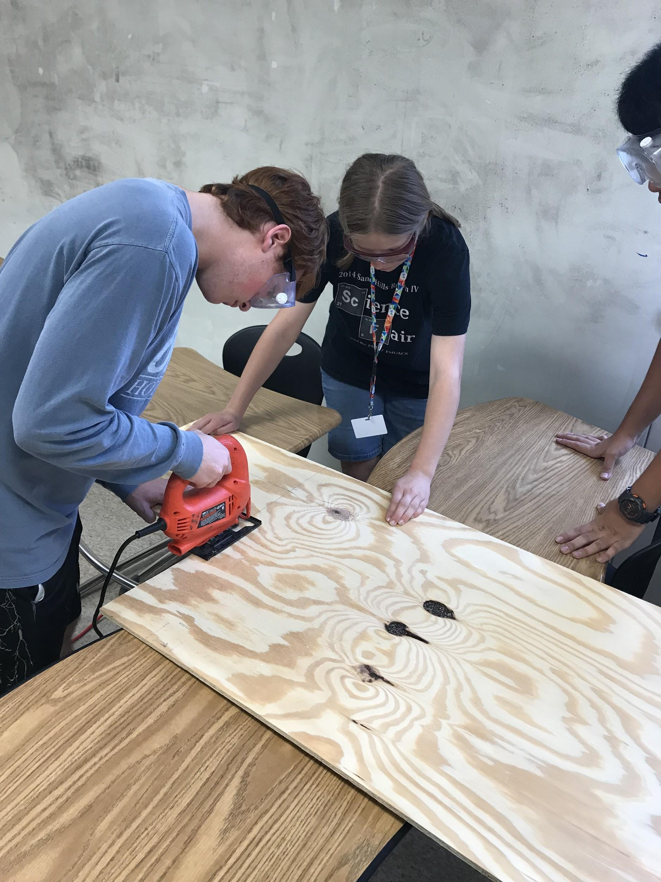

Figure 5.2

Like Figure 5.1 it shows precaution of safety